CREATE NODE-RED

|  |  |
| --- | --- |
| **Date** | 11 November 2022 |
| **Team ID** | PNT2022TMID24187 |
| **Project title** | Smart Farmer-IoT Enabled smart Farming Application |

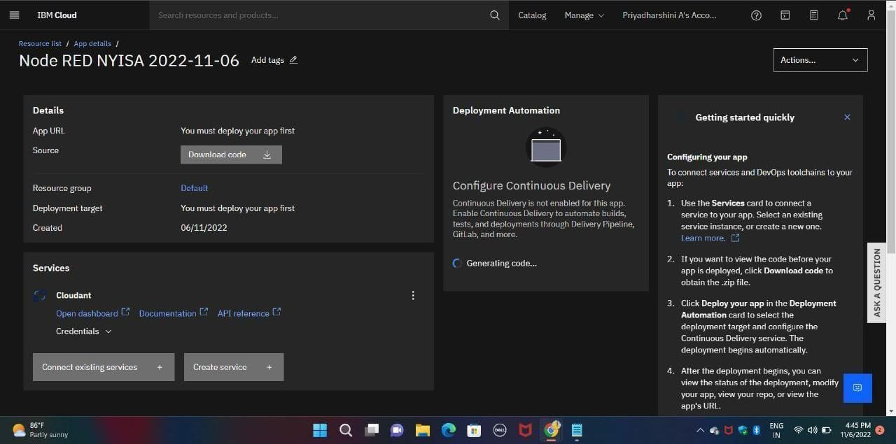

Step 2:

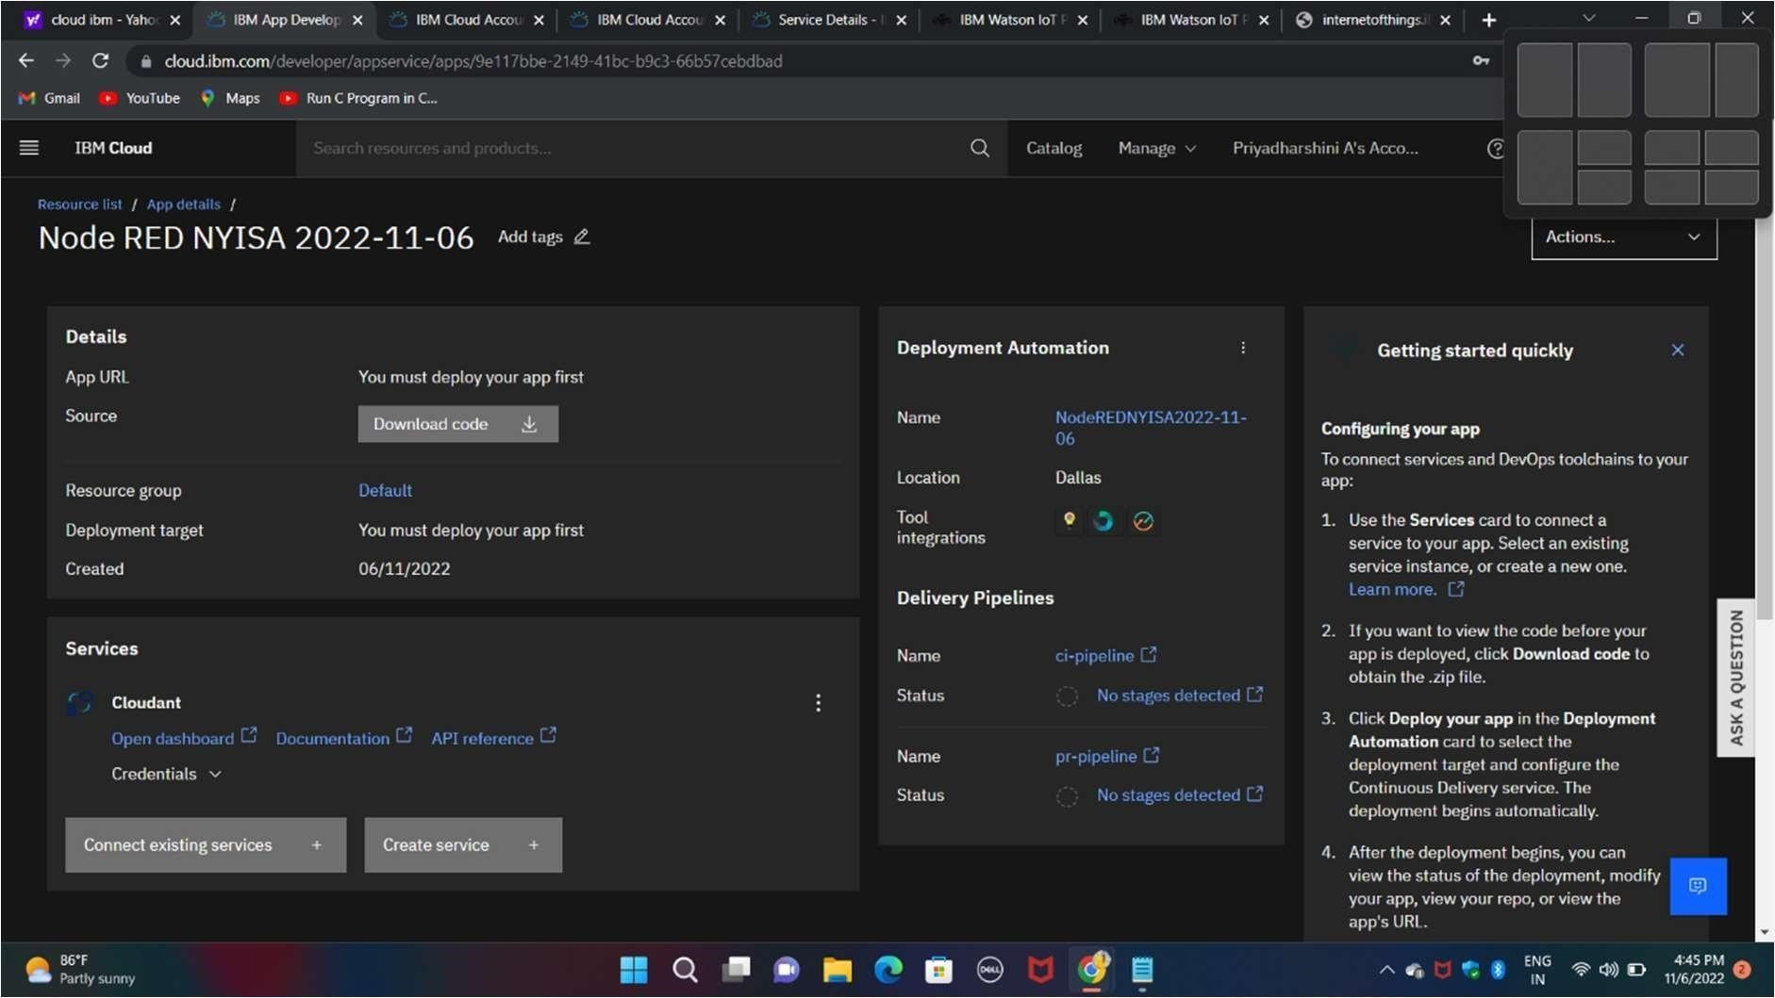

Step 3:

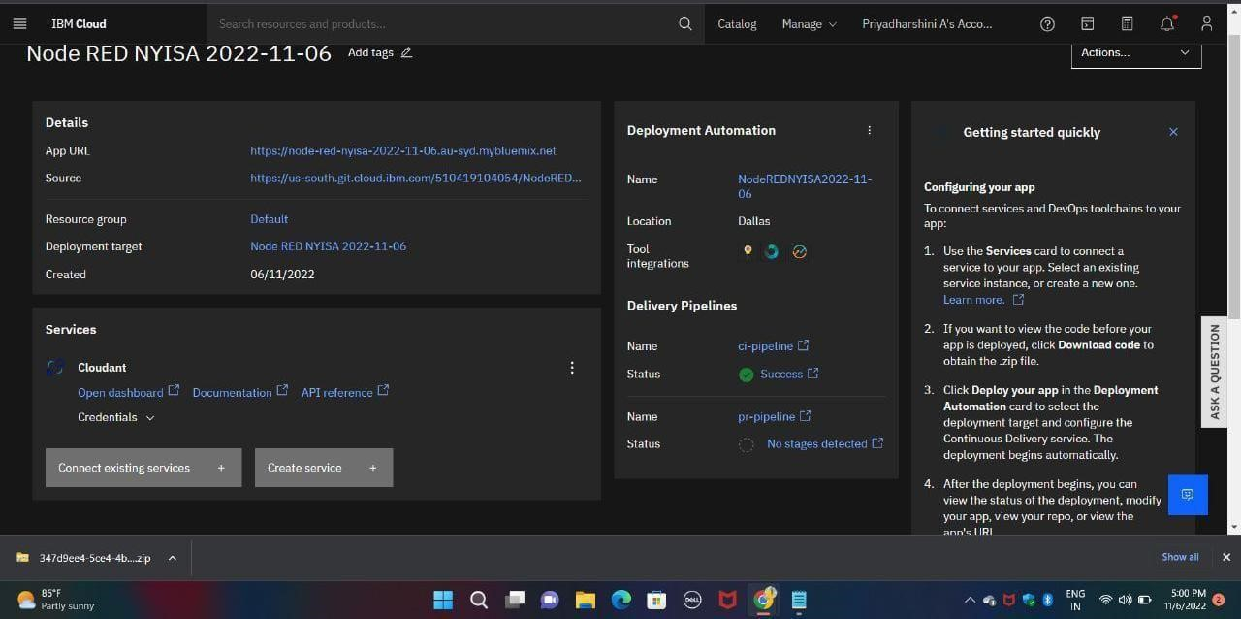

Step 4:

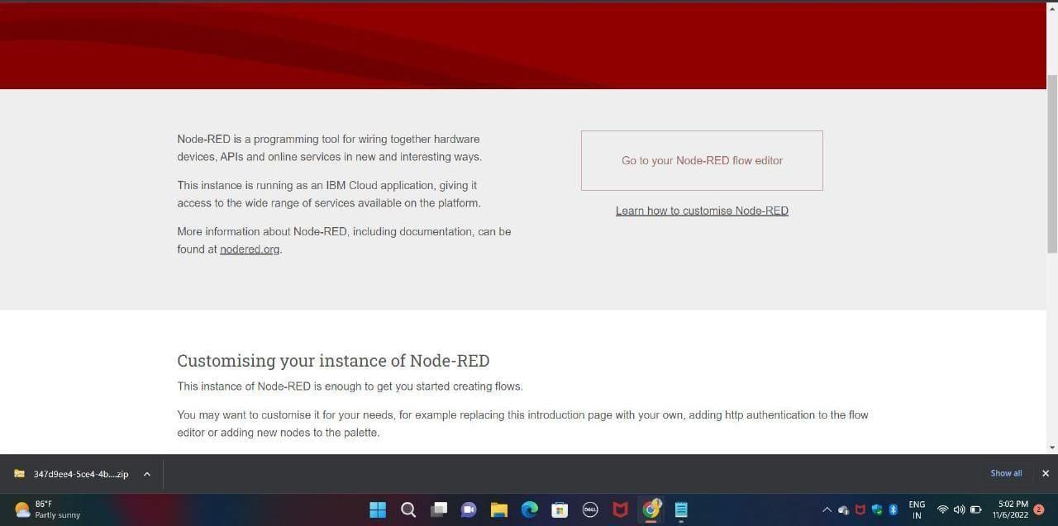

Step 5:

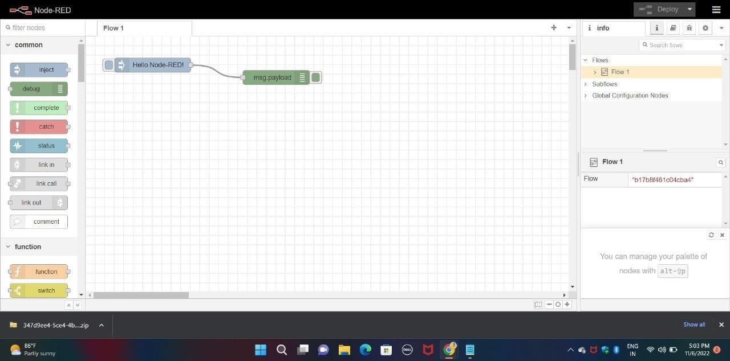

Step 6:

